Wojciech Kubiak

Zadanie 1.

1. f (x, y) = (¬ x $∪$ ¬ y) $∩$ ¬ ( y $∪$ ¬ x ) = ¬ y $∩$ x

|  |  |  |
| --- | --- | --- |
| x | y | x |
| 0 | 0 | 0 |
| 0 | 1 | 0 |
| 1 | 0 | 1 |
| 1 | 1 | 0 |

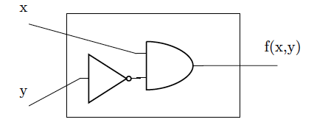

1. f ( x, y, z ) = ¬ z $∪$ ( x $∩$ y $∩$ ¬ z ) = ¬ z

|  |  |  |  |
| --- | --- | --- | --- |
| x | y | z | ¬ z |
| 0 | 0 | 0 | 1 |
| 0 | 0 | 1 | 0 |
| 0 | 1 | 0 | 1 |
| 0 | 1 | 1 | 0 |
| 1 | 0 | 0 | 1 |
| 1 | 0 | 1 | 0 |
| 1 | 1 | 0 | 1 |
| 1 | 1 | 1 | 0 |

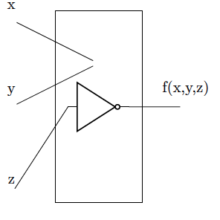

1. f ( x ) = ¬ x $∩$ x

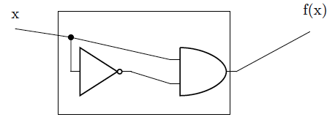

|  |  |
| --- | --- |
| x | ¬ x $∩$ x |
| 0 | 0 |
| 1 | 0 |

|  |  |  |
| --- | --- | --- |
| x | y | x |
| 0 | 0 | 0 |
| 0 | 1 | 0 |
| 1 | 0 | 1 |
| 1 | 1 | 0 |

1. f ( x, y, z ) = x $∪$ y $∪$ ( ¬ x $∩$ ¬ z )

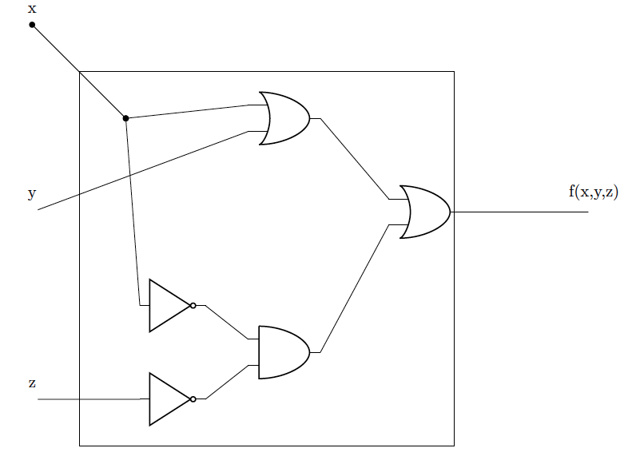

|  |  |  |  |
| --- | --- | --- | --- |
| x | y | z | x $∪$ y $∪$ ( ¬ x $∩$ ¬ z ) |
| 0 | 0 | 0 | 1 |
| 0 | 0 | 1 | 0 |
| 0 | 1 | 0 | 1 |
| 0 | 1 | 1 | 1 |
| 1 | 0 | 0 | 1 |
| 1 | 0 | 1 | 1 |
| 1 | 1 | 0 | 1 |
| 1 | 1 | 1 | 1 |

Zadanie 2.

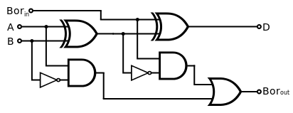

${Bor}_{in}$ = x

A = y

Bor = z

D = f ( x, y, z )

${Bor}_{out}$ = g ( x, y, x )

xor ( a, b ) = ( a $∪$ b ) $∩$ ( ¬ a $∪$ ¬ b )

f ( x, y, z ) = ((( x $∪$ y ) $∩$ (¬ x $∪$ ¬ y )) $∪$ z ) $∩$ (¬ (( x $∪$ y ) $∩$ ( ¬ x $∪$ ¬ y )) $∪$ ¬ z) =

= ((( x $∪$ y ) $∩$ (¬ x $∪$ ¬ y )) $∪$ z ) $∩$ ((( ¬ x $∪$ ¬ y) $∪$ ( x $∩$ y ) $∪$ ¬ z =

|  |  |  |  |
| --- | --- | --- | --- |
| x | y | z | (¬ x $∩$ y) $∪$ (¬ x $∩$ z ) $∪$ ( y $∩$ z ) |
| 0 | 0 | 0 | 0 |
| 0 | 0 | 1 | 1 |
| 0 | 1 | 0 | 1 |
| 0 | 1 | 1 | 1 |
| 1 | 0 | 0 | 0 |
| 1 | 0 | 1 | 0 |
| 1 | 1 | 0 | 0 |
| 1 | 1 | 1 | 1 |

= ( x $∩$ y $∩$ z ) $∪$ ( x $∩$ ¬ y $∩$ ¬ z ) $∪$ (¬ x $∩$ y $∩$ ¬ z ) $∪$ (¬ x $∩$ ¬ y $∩$ z )

g ( x, y, z ) = ((¬ x $∩$ y) $∪$ (¬ ((x $∪$ y) $∩$ (¬ x $∩$ ¬ y)) $∩$ z )) $∩$ (¬ ( ¬ x $∩$ y) $∪$ ¬ ( ¬ ((x $∩$ y) $∩$ (¬ x $∪$ ¬ y)) $∩$ z )) = (¬ x $∩$ y) $∪$ (¬ x $∩$ z) $∪$ (( y $∩$ z)

|  |  |  |  |
| --- | --- | --- | --- |
| x | y | z | (¬ x $∩$ y) $∪$ (¬ x $∩$ z ) $∪$ ( y $∩$ z ) |
| 0 | 0 | 0 | 0 |
| 0 | 0 | 1 | 1 |
| 0 | 1 | 0 | 1 |
| 0 | 1 | 1 | 1 |
| 1 | 0 | 0 | 0 |
| 1 | 0 | 1 | 0 |
| 1 | 1 | 0 | 0 |
| 1 | 1 | 1 | 1 |

Zadanie 3.

|  |  |  |  |
| --- | --- | --- | --- |
| a | b | c | a $∩$ ¬ c $∩$ ¬ b |
| 0 | 0 | 0 | 0 |
| 0 | 0 | 1 | 0 |
| 0 | 1 | 0 | 0 |
| 0 | 1 | 1 | 0 |
| 1 | 0 | 0 | 1 |
| 1 | 0 | 1 | 0 |
| 1 | 1 | 0 | 0 |
| 1 | 1 | 1 | 0 |

f ( a, b, c ) = ¬ ( a $∩$ b $∩$ c ) $∩$ (¬ a $∪$ ¬ b $∪$ c ) $∩$ ( a $∩$ ¬ c ) $∩$ ( a $∩$ ¬ b $∩$ c ) =

= (¬ a $∩$ ¬ b $∩$ ¬ c ) $∩$ (¬ a $∪$ ¬ b $∪$ c ) $∩$ ( a $∩$ ¬ c ) $∩$ ( a $∩$ ¬ b $∩$ c ) =

= (a $∩$ ¬ c ) $∩$ (¬ b ) $∩$ (¬ b ) $∩$ (a $∩$ ¬ b ) =

= a $∩$ ¬ c $∩$ ¬ b